Question 1: Library Management System – Use Case Diagram
Scenario:
A college library currently maintains book issue and return records manually. Students often face
delays while borrowing books because the librarian has to verify availability using registers.
Faculty members can reserve books in advance, while librarians can add, update, and remove
books from the catalog. Students can search books by title, author, or category. The librarian also
calculates overdue fines and generates monthly reports. The college administration wants an
automated system that provides faster services and minimizes manual errors. The system should
also allow users to log in securely. Notifications should be sent for overdue books. Different
users should have different access rights. As a system analyst, identify the actors and their
interactions.
Lab Activity:
Design the Use Case Diagram for the Library Management System.

SOLUTION - USE CASE DIAGRAM

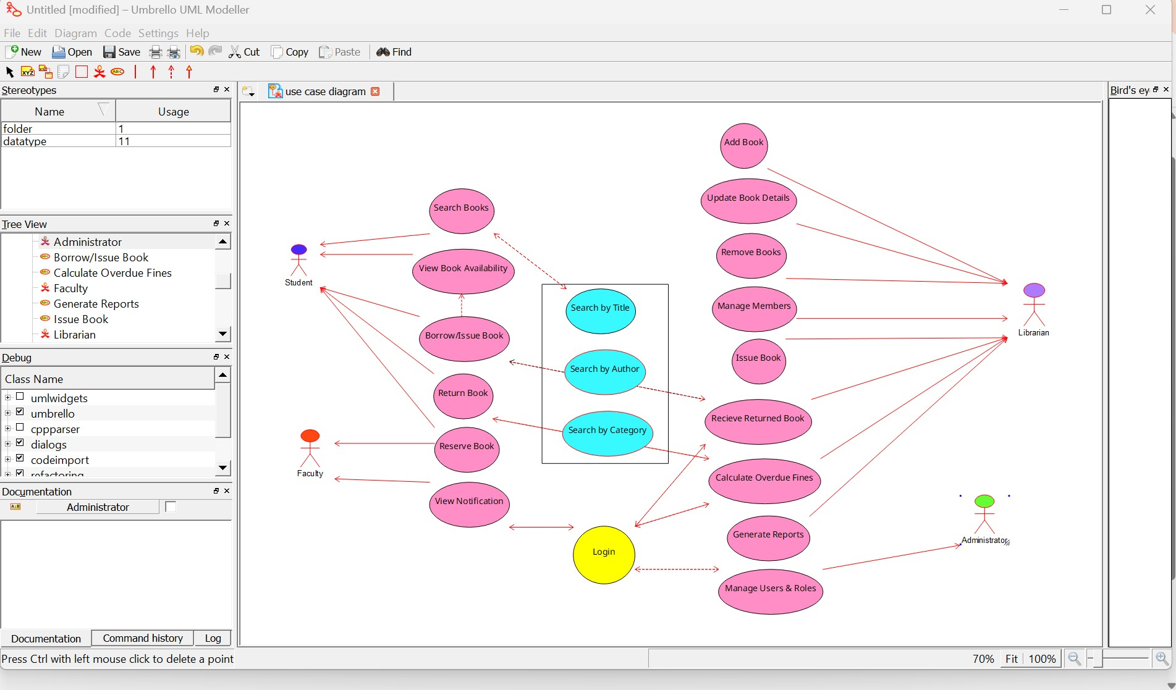
Question 2: Hospital Management System – Class Diagram
Scenario:
A multispecialty hospital wants to automate patient management. Patients can register online,
schedule appointments, and access medical reports. Doctors diagnose patients and prescribe
medicines. Receptionists manage appointments and billing. Pharmacists issue medicines based
on prescriptions. The billing department calculates treatment charges and insurance claims. Each
patient has a unique medical history. Doctors belong to different departments. The hospital
administrator manages staff information. Design the object-oriented structure for this system.
Lab Activity:
Create a Class Diagram showing classes, attributes, methods, and relationships.

SOLUTION - USE CASE DIAGRAM

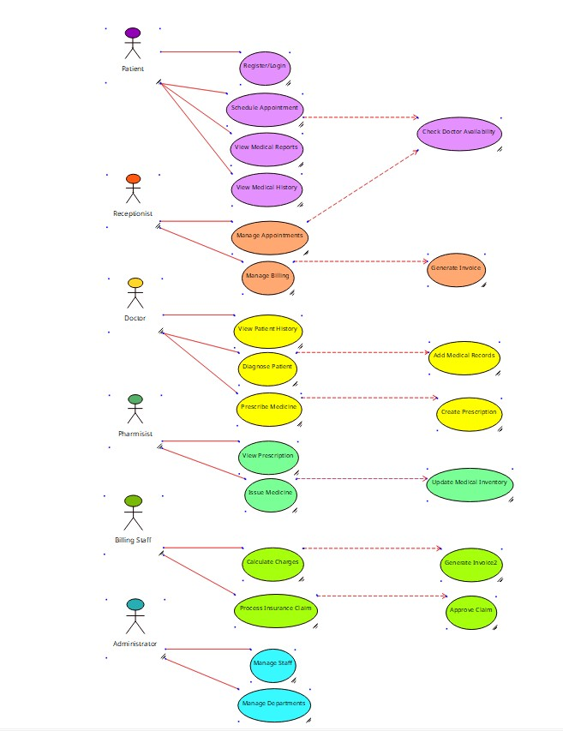

Question 3: Online Shopping System – Sequence Diagram
Scenario:
An online shopping application allows customers to browse products, add items to a cart, place
orders, and make online payments. After successful payment, inventory is updated automatically
and an order confirmation email is sent. If payment fails, the customer is prompted to retry.
Warehouse staff process confirmed orders for shipping. Customers can track their order status.
The payment gateway validates transactions securely. Discounts are applied automatically during
checkout. Customer support handles order cancellation requests. The company wants to
understand the interaction between system objects during purchase.
Lab Activity:
Develop a Sequence Diagram for the order placement process.

SOLUTION - USE CASE DIAGRAM

